Completed | Name | Needed to Complete Application
 | Project Location Map | Required Document
 | Existing & proposed typical section(s) for this project. | Required Document
 | Detailed scope for the proposed project. (including specific improvements/elements) | Required
 | Map(s) denoting the Right-of-Way for the project (Right-of-Way map, Plat, Survey) | Required Document
 | Resolution from the applicant's governing board approving the specific project. | Required  Document
 | Resolution from the governing board that has ownership of the associated right-of-way where the project is proposed approving the specific project (can be combined with #4). | Required  Document
 | Resolution from the responsible governing board confirming commitment to fund the project's O&M (can be combined with #4 or 5). | Required  Document
 | Detailed public support (how community support for the project was gathered and evaluated, including consideration from Title VI and Environmental Justice populations.) | Required Document
 | Completed FDOT Cost Estimate Form. | Required Document
 | Page(s) from local plan or program that references the project. | If Applicable
 | Provide any supporting data and technical analysis referenced in the Purpose and Need (ex: traffic study for a lane elimination proposal). | If Applicable
 | If the project is part of a Broward MPO endorsed corridor study, include page(s) where the project is referenced. | If Applicable
 | If the project is adjacent to any upcoming or currently underway projects, then provide available documentation verifying adjacent projects. | If Applicable

How to Get Organized
The online application must be completed all at once. You will be able to upload your documents directly through the online application. However, if your document is larger than 10 MB, you will need to reach out to the CSLIP Manager and request a link to upload additional documents. If you are well organized before, the application and document upload should only take about 25-35 minutes to complete.
Before filling out the application online, please review Application Copy which is available on our website at https://www.browardmpo.org/cslip-application-information. The Application Copy can be used to create a document with all of your answers in it, from there you can copy and paste the answers into the online application. This process is recommended because the online application does not have grammar check capabilities or good editing functions. Several documents will have to be uploaded as part of the application. It is best to create a folder on your desktop and copy all of the document that you will need into the single location (Image 1). As shown in Image 1, files have been renamed to match the question they will be used for. For the sake of keeping everything in one location, you can create another folder and place your Word Document and the folder with your files for upload in it (Image 2).

Image 1
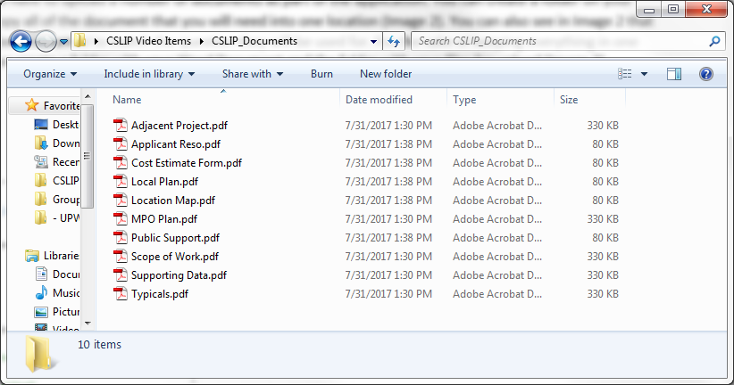

Image 2
